**Project Design Phase-II**

**Technology Stack (Architecture & Stack)**

|  |  |
| --- | --- |
| Date | 21 October 2022 |
| Team ID | PNT2022TMID47551 |
| Project Name | Digital Naturalist - AI Enabled tool for  Biodiversity Researchers |
| Maximum Marks | 4 Marks |

**Technical Architecture:**

The Deliverable shall include the architectural diagram as below and the information as per the table1 & table 2

**Image recognition and Categorical Search:**

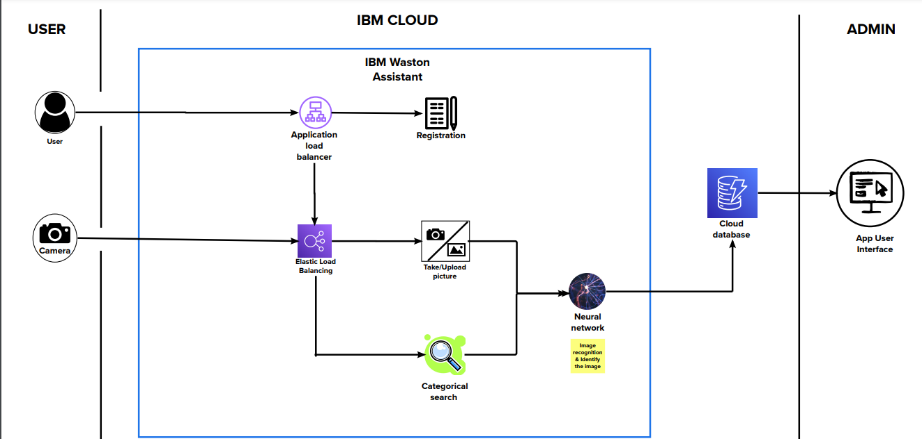

**Table-1 : Components & Technologies:**

|  |  |  |  |
| --- | --- | --- | --- |
| **S.No** | **Component** | **Description** | **Technology** |
|  | User Interface | How user interacts with application e.g.  Web UI, Mobile App, Chatbot etc. | HTML, CSS, JavaScript, WSDL, SOAP |
|  | Application Logic-1 | Logic for a process in the application | Python |
|  | Application Logic-2 | Logic for a process in the application | IBM Watson Assistant |
|  | Application Logic-3 | Logic for a process in the application | NLP |
|  | Database | Data Type, Configurations etc. | MySQL |
|  | Cloud Database | Database Service on Cloud | IBM DB2, IBM Cloudant . |
|  | File Storage | File storage requirements | Local File system |
|  | External API-1 | Purpose of External API used in the application | Image API |
|  | External API-2 | Purpose of External API used in the application | REST API |
|  | Machine Learning Model | Purpose of Machine Learning Model | Object Recognition Model, Image Recognition Model |
|  | Infrastructure (Server / Cloud) | Application Deployment on Local System / Cloud  Local Server Configuration:  Cloud Server Configuration : | Local Server configuration, IBM cloud |

**Table-2: Application Characteristics:**

| **S.No** | **Characteristics** | **Description** | **Technology** |
| --- | --- | --- | --- |
|  | Open-Source Frameworks | List the open-source frameworks used | Jupyter |
|  | Security Implementations | List all the security / access controls implemented, use of firewalls etc. | Firewall, encryption and decryption, IAM Controls, OWASP |
|  | Scalable Architecture | Justify the scalability of architecture (3 – tier, Micro-services) | 3 – tier architecture (user-IBM cloud-admin) |
|  | Availability | Justify the availability of application (e.g. use of load balancers, distributed servers etc.) | Elastic load balancer, Application load balancer |
|  | Performance | Design consideration for the performance of the application (number of requests per sec, use of Cache, use of CDN’s) etc. | Use of CDN’s, Use of catch, Use of requests per sec. |